# PH102 Project Report

Velocity Chronometer

Team Members:

* Chirag Tayal – 2023EEB1195
* Devansh Arora – 2023EEB1196
* Divyanshu Kumar Verma – 2023EEB1197
* Ekam Sandhu – 2023EEB1198
* Elaine Anna Joseph – 2023EEB1199

Objective: To measure the velocity of an object moving in 1-D with the help of a photoresistor.

Acknowledgement:

Many people have sent us their invaluable assistance in the successful completion of our Project.

First of all, we would like to thank Dr. Mukesh Kumar for giving us this chance to learn and for his encouragement during the course of the project. His recommendations and guidance were crucial in getting this project finished.

We also want to thank our TAs for always being available to us when we needed advice.

Their insightful suggestions enabled us to successfully complete this assignment.

Material Required:

* Arduino Uno SMD Board
* Jumper Wires
* Photoresistor
* 840 Tie Point Breadboard
* LED Light
* Known Resistances
* Potentiometer
* A working PC

Basic principle: A velocity chronometer is based on the simple principle of working of a photoresistor.

*Photoresistors are light-sensitive resistors whose resistance decreases as the intensity of light they are exposed to increases.*

A photoresistor or light-dependent resistor is composed of photo-conductor material. When light hits a material of such kind, the material absorbs the radiation, and electrons move from the valence band of the semiconductor to the conduction band. More the electrons in the conduction band of the resistor, the less the resistance of the resistor. We know that the Intensity of light is inversely proportional to the square of the distance between the moving body and the photoresistor. This principle is known as the inverse square law.



The object connected to a light source varies its position with respect to the photoresistor, varying the intensity of light falling on it. This changes the resistance across LDR connected in series with another known resistance. This leads to variation in voltage across the known resistance.

Theory:

Photoresistors, also known as light-dependent resistors, are components made of semiconductors. Modern light-dependent resistors are made of lead sulfide, lead selenide, indium antimonide, and most commonly cadmium sulfide and cadmium selenide.

When the light falls on the photoresistor, some of the valence electrons absorb energy from the light and break the bonding with the atoms. The valence electrons, which break the bonding with the atoms, are called free electrons.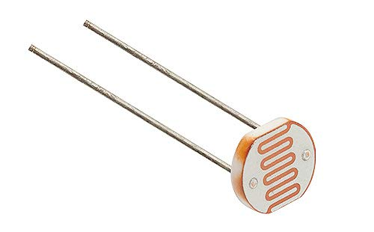 When the light energy applied to the photoresistor is highly increased, a large number of valence electrons gain enough energy from the photons and break the bonding with the parent atoms. The large number of valence electrons, which breaks the bonding with the parent atoms will jump into the conduction band.

The electrons present in the conduction band do not belong to any atom. Hence, they move freely from one place to another place. The electrons that move freely from one place to another place are called free electrons. When the valence electron leaves the atom, a vacancy is created at a particular location in the atom from which the electron is left. This vacancy is called a hole. Therefore, the free electrons and holes are generated as pairs. The free electrons that are moving freely from one place to another place carry the electric current. In a similar way, the holes moving in the valence band carry electric current.

The amount of electric current flowing through the photoresistor depends on the number of charge carriers (free electrons and holes) generated. When the light energy applied to the photoresistor increases, the number of charge carriers generated in the photoresistor also increases. As a result, the electric current flowing through the photoresistor increases. An increase in electric current means a decrease in resistance. Thus, the resistance of the photoresistor decreases when the intensity of applied light increases.

Velocity is a quantity that is widely involved in many practical regions and various velocity measurement methods and devices have been developed. In this project, we measure the velocity using a photoresistor whose resistance decreases with an increase in intensity as mentioned and explained above.

Working: When the position of the moving object containing LED is varied with respect to the photoresistor, a change in voltage is observed across the known resistance connected in series with the photoresistor. This change in voltage with respect to a standard time interval (manually set as 10 ms) is observed and recorded by the Arduino UNO. The Arduino UNO is a microcontroller that easily connects to the computer system via a USB Port and acts as a serial device to connect the board to a computer system. The values of change in voltage with respect to time are read by the computer system as analog reading and converted to voltage. This value of voltage is thereafter converted to velocity using another Code run on Arduino IDE (Arduino Integrated Development Environment) and also plotted.

Graph plotting: The graph plotted is a velocity with time graph where the x-axis represents the time function and the y-axis represents the velocity function. The slope of the graph gives the Acceleration of the moving body.

Circuit diagram:

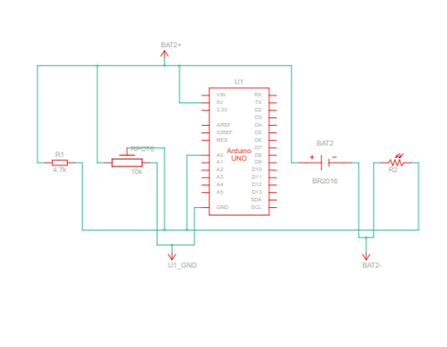

The circuit diagram comprises the following components:

1. Potentiometer
2. Photoresistor
3. Arduino Uno
4. Battery
5. Resistor
6. Jumper wires
7. Breadboard

Potentiometer: A potentiometer is a simple mechanical device that comes in many different forms. It provides a variable amount of resistance that changes as you manipulate it. One outer pin of the potentiometer is connected to the ground, and other external pin is connected to 5V of the Arduino board. The middle pin of the potentiometer is connected to the analog input pin A0 of the board.

By passing voltage through a potentiometer and into an analog input on board, it is possible to measure it as an analog value.

Photoresistor: The photoresistor is a sensor whose resistance varies with light intensity.

Arduino Uno: Arduino UNO reads analog inputs from the circuit and converts them into voltage values using a code. It feeds the input into our computer.

Battery: The battery is used to provide a voltage across the circuit.

Resistor: The resistor is used to provide a potential drop.

Theoretical Calculations:

The resistance across a photoresistor as a function of intensity of incident light can be written as (cited as [1])



Therefore,



From the circuit diagram, the potential drop across the known resistance R0 is a function of distance between the object under consideration and the photoresistor, x;

By voltage divider formula,



Therefore,



Taking derivatives on both sides,



Velocity is



Approximating R (resistance of photoresistor) between x1 and x2,



In the limits of our experiment,

x1 = 0

x2 = 0.5m

Experiments were performed in the lab using a photoresistor and standard green LED light to determine the constants A and B in the resistance equation. The determined values were

A = 8999.295677 Ω

B = 0.1167681409 $m^{2}$

Thus, average value of R is

R = 4579.527284 Ω

Putting all values in our velocity equation,



Where δ = 0.19265388 m $V^{-1}$

This equation can be used to find speed of the projectile under study by measuring the voltage change across the resistor.

Applications of velocity chronometer in daily life:

* Gives you the sketch of velocity versus time.
* Helps you determine even the smallest variation in the velocity of fast-moving body.
* It can be used for tracking vehicle velocities for safety and efficiency, monitoring commute times, measuring running speeds in sports activities etc.

Code:

The code snippet attached below helps to read voltage from Arduino and convert it into velocity.

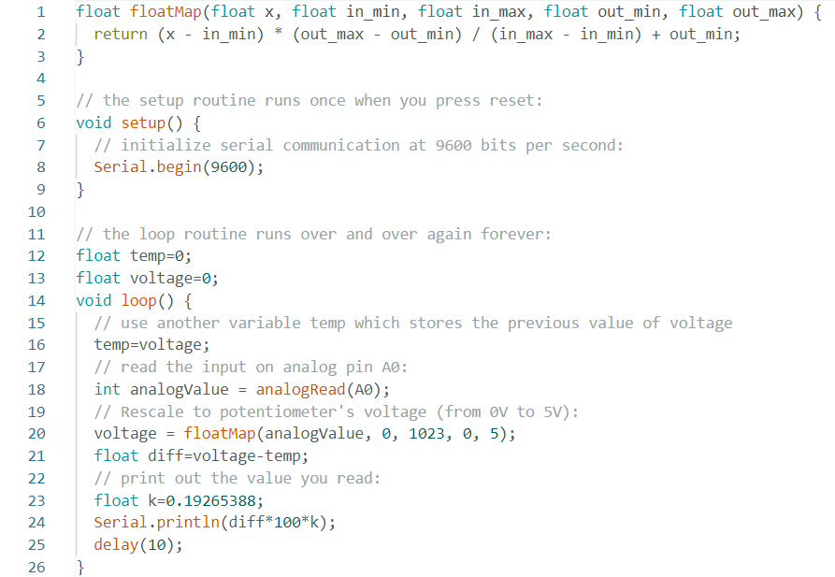

Sources of error:

* Photo resistors are highly sensitive to light so while determining the variation in resistance with the intensity of light from the moving body even the small fluctuations in external light (even the light from Arduino and surroundings) affect the voltage and thereby affect the value of velocity.
* Velocity of only those objects within a range of 50cm can be measured.
* There will be manual calculation errors present during the calculation of constants to be used in the resistance-velocity equation.
* The object should be moving only in one dimension. There should not be any angle between the falling light and the photoresistor.
* Arduino connected to the circuit has a tendency to supply power to the circuit.

Conclusion:

By the end of this project, we were able to create a device that is useful in measuring the velocity of objects within given ranges of 1D motion. This project was a wonderful learning opportunity, and we anticipate having more of them in the future.

Citations:

[1] <https://ieeexplore.ieee.org/document/8727728>

Contributions:

2023EEB1195- Chirag Tayal

* Calibrated the values for the formula
* Skilfully tested the project

2023EEB1196- Devansh Arora

* Coding for the Arduino
* Devised the project idea

2023EEB1197- Divyanshu Kumar Verma

* Devised the project idea
* Researched the working of the project

2023EEB1198- Ekam Sandhu

* Theorized the project on paper
* Assembly of the project model

2023EEB1197- Elaine Anna Joseph

* Researched sources of error and applications
* Skilfully tested the project